Student’s Name: Kibet Brian
Admission Number: 190814
Lecturer’s Name: Mr. Talo Harrison
Course Unit: MST 8303 Penetration Testing, PT
Course Code: MST 8303
Lab - Installing w3af in Kali Linux Using Docker
Date: July 7th, 2025

Lab - Installing w3af in Kali Linux Using Docker
vim docker_install.sh
Writing to docker_install.sh file
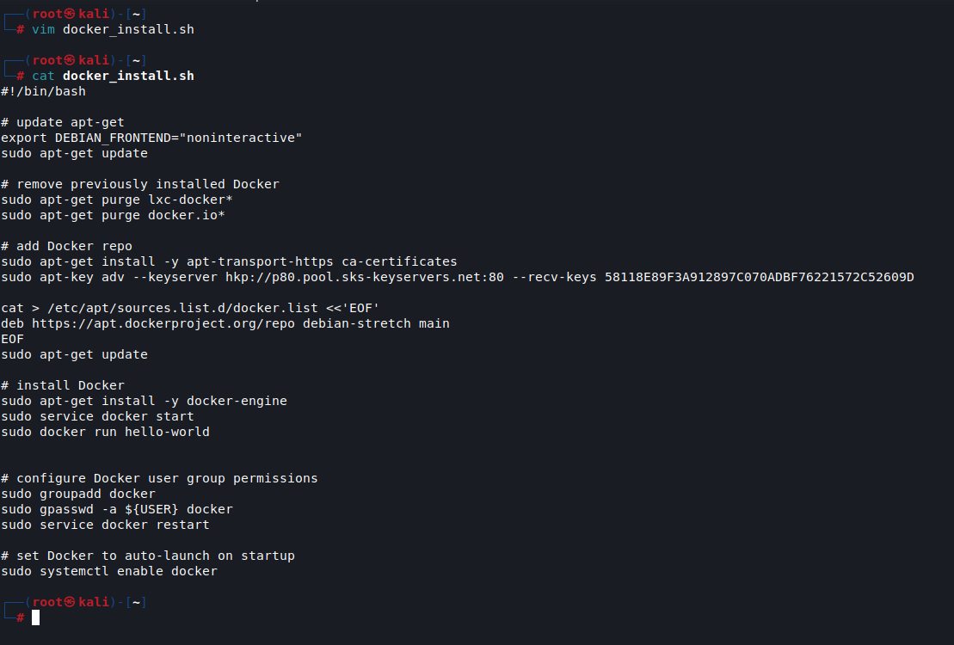

Showing and making the file executable.
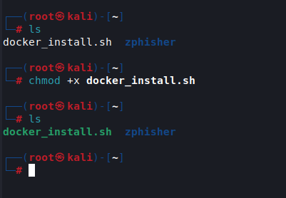

sh docker_install.sh
Installing docker.
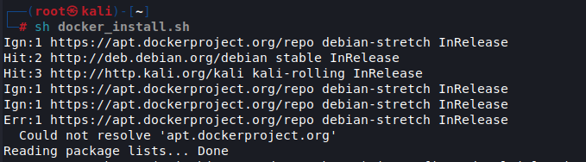

Confirming docker is installed: docker run hello-world
